Cessna Auxiliary Fuel Tanks

Cessna 150 & 152 - 14.6 Gallons



Cessna 172 & 182 - 18 Gallons



Cessna 210 & T210 - 18 or 28 Gallons



Cessna P210 - 29.7 Gallons



Grumman AA5, AA5A, AA5B - 18 Gallons



Twin Cessna Locker Tanks - 18.5 Gallons



Cessna 150 & 152 Commercial Craft

14.6 Gallons    
  
Constructed of heavy gauge aluminum, the tank occupies part of the baggage area, with plenty of room left over for luggage. To operate, the pilot simply turns on a switch to start fuel transfer when the right main tank is two-thirds full. An electric pump transfers fuel into the right wing at approximately 6 gallons per hour. An indicator light in the cockpit is illuminated while fuel is flowing. A mechanical gauge is mounted on top of the tank.   When the tank runs empty, the pump shuts off automatically.

A flush-mounted external filler cap is installed on the right side of the aircraft, a popular feature among users of auto gas. 20 Man-Hours required for installation.  
Empty Weight: 15.2 lbs. Dimensions: 9"x30"x17"

View of 150 Fuel Tank Installation Before Re-Covering With Carpet

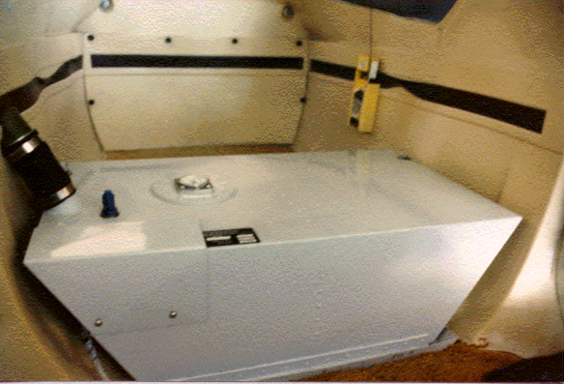

Cessna 172 & 182

18 Gallons  
  
Designed to conserve valuable luggage area, the all-welded aluminum tank is installed in the aft baggage compartment, raising the floor approximately five inches above the base of the door. To operate, the pilot burns off approximately one-fourth of the fuel from the right main tank.  By turning on a switch located near the fuel selector, transfer is initiated. An electric fuel pump transfers fuel at the rate of burn (set for your model ~ between 8 and 12 gallons per hour).  When the auxiliary tank runs empty, the pump shuts off automatically and the light goes out.  Installation requires approximately 25 Man-Hours.



Cessna 210, T210 & P210

18 Gallons - STC'd for Cessna 210 & T210, Models L, M, N, R

28 Gallons - STC'd for Cessna 210 & T210, Models  N, R

29.7 Gallons - STC'd for Cessna P210, Models N,R

Made of all welded aluminum, these tanks are engineered to utilize weight and balance limitations to compensate for the weight of additional fuel. The design conserves as much space as possible since the tank fits efficiently onto the floor of the baggage compartment, and will support baggage weight when not in use.    The 28-gallon and 29.7-gallon tanks are flush with the door of the baggage compartment; the 18-gallon tank raises the floor of the baggage compartment by only four inches.  A quantity gauge, flow light, and switch are installed near the fuel selector in the cockpit.   After one-fourth of the right main tank is burned off, the pilot turns on the switch to initiate fuel transfer. An electric pump transfers fuel at approximately 17 gallons per hour. The amber light indicates that fuel is flowing. When the tank runs empty, it shuts off automatically.  The kit includes a new lightning- proof external filler cap and comes with lifetime warranty. Installation requires approximately 25 Man-Hours.

                18-Gallon Tank: Empty Weight - 18.5 lbs.    
                28-Gallon Tank: Empty Weight - 22.5 lbs.    
                29.7-Gallon Tank: Empty Weight 22.0 lbs.

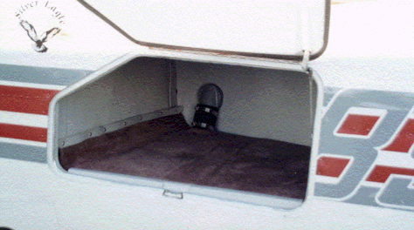

Cessna P210 Baggage Tank with plenty of room left over for luggage